

Solution Design & Architecture

Smart Recommendation System

# 

# 

# Introduction & Background

Shopping is a necessity of every human being, and when we do shop it’s definitely either the product we like or our friends like. We tend to buy products recommended by people because we trust the person. And nowadays in the digital age, any online shop you visit utilizes some sort of recommendation engine.

And if it is set up and configured properly, it can significantly boost revenues, CTRs, conversions, and other important metrics. Moreover, they can have positive effects on the user experience as well, which translates into metrics that are harder to measure but are nonetheless of much importance to online businesses, such as customer satisfaction and retention.

Present day recommendation engines use a user’s browsing history, previous orders and the features of products to recommend but don’t take into consideration the personality of the user, his way of thinking and his approach to buy a product. Presently, customers have to scroll through hundreds of products to find the one that appeases them the most. Specifically on shopping platforms for clothing, furnishing etc. where liking to a product is very subjective.

We provide a solution to the mentioned issue by proposing a Smart Recommendation System. This system would try to get insights into the user’s personality, initially by responses of the customer to few questions asked in the beginning to judge their personality type. This would then be used a feature along with the previous features which were already in use in present models to build a strong & smart recommendation engine.

|  |  |
| --- | --- |
| Overview: Solution Architecture | |
| Type | IT Architecture |
| Definition | A Smart recommendation engine that would not only take a user’s browsing history and products bought previously and the features of the products but also the personality of an individual, his/her way of thinking based on their responses to few questions. |
| Related Concepts | * Machine Learning * A collaborative Recommendation engine * Deploying it on test cases |

# 

# Basic Intuition

Consider a new user enters an ecommerce platform with this smart recommendation system deployed as a filter feature on it. The user will be notified to give responses to a few questions, ideally only a few like five to six during the process of creating an account on this ecommerce platform.

These questions are designed in such a way that they will be roughly able to portray the user’s personality and hence better guess his likes and dislikes in aspects like, design, aesthetics, preferences etc. Scientifically guessing such features about a user can be done by using the **Big Five personality model (OCEAN)**.

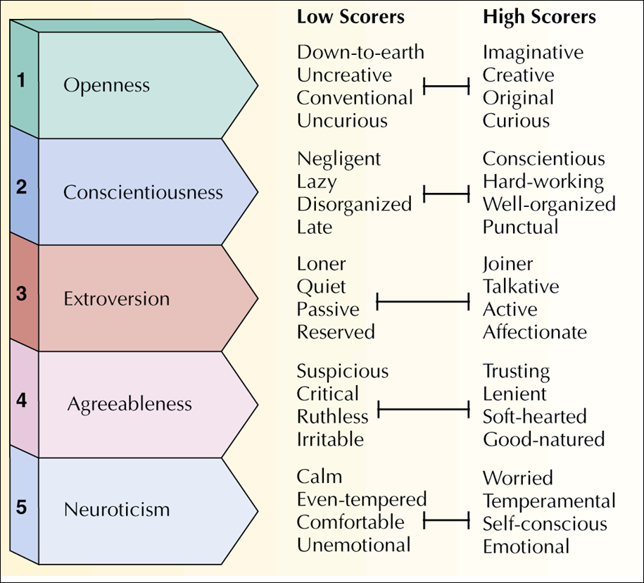

These factors generalizing personality of people can also reveal how and what a user might choose/prefer for purchase and even how the product should be portrayed to the customer to increase chances of buying.

For example:

* A person with high score in Conscientiousness is more likely to prefer simple and minimalistic designs in his choices of products along with some emphasis to decent as thetics.
* A person with high agreeableness will tend to easily fall for brand value.
* A person with high neuroticism will choose higher overall appeal of the product to others.

**Thus it is easy to see that this approach can help us deduce some very strong inferences with much reduced feature set as against the conventional approach.**

More on how users with specific personality types behave while shopping:

[PERSONALITY INFLUENCES ON ONLINE STORES CUSTOMERS BEHAVIOR](https://www.google.com/url?sa=t&rct=j&q=&esrc=s&source=web&cd=12&ved=2ahUKEwjXidWwl7ThAhWEfisKHehXBpEQFjALegQIAhAC&url=http%3A%2F%2Fwww.ecoforumjournal.ro%2Findex.php%2Feco%2Farticle%2Fdownload%2F125%2F94&usg=AOvVaw2T6_srkzS7tRtJ-cM9-0xB)

[WHY DO CONSUMERS MAKE ONLINE SHOPPING? THE EFFECT OF BIG FIVE PERSONALITY TRAITS, NARCISSISM AND SELF-ESTEEM](https://pdfs.semanticscholar.org/8908/3607f6c78b8da22141ff283ea281efb13bb4.pdf)

# 

# Project Description

We intend to make a Machine Learning Recommendation Engine that learns these types of patterns in the relationship of a product and a customer. It has two stages of operation:

1. User Personality/Psychology Prediction (Based on Big Five)
2. Smart Recommendation Engine

Our system will be able to learn a user’s personality by analyzing their response to some carefully engineered questions. These questions can me a mix of pictorial and textual representations and also limited in number to avoid user frustration/boredom.

More on how textual and pictorial informations are related to the big five model:

[Deep Inference of Personality Traits by Integrating Image and Word Use in Social Networks](https://arxiv.org/pdf/1802.06757.pdf)

An Example on how the questions might look like:

[Example questions](https://docs.google.com/document/d/1Wi9--caGiFh_b_PnNXh_BEBjtrdQHRqqgfwBoM299tc/edit?usp=sharing)

**The thought process behind the solution:**

* + Ask a user questions (pictorial/text), carefully designed to make descent predictions about the user’s personality type.
  + Classify users based on their personality type. Identify which type of customers like what type of items and show them those items first.
  + Prediction for frequent customers can be improved with other obvious features like product characteristics, ratings, reviews offered by the e-commerce platform for the same.
  + A system that can do this will be smart, personalized and enhance customer engagement, leading to retention

**Dataset Used to make a sample prototype of the proposed Idea:**

[**Amazon Fine Food review dataset**](https://www.kaggle.com/snap/amazon-fine-food-reviews)

**Amazon Fine Food review Dataset Includes:**

1. Reviews from Oct 1999 - Oct 2012
2. 568,454 reviews
3. 256,059 users
4. 74,258 products
5. 260 users with > 50 reviews

**User Personality/Psychology Prediction Stage:**

A user dataset was created based on responses to a few questions (Ideally only a few like 4 to 5) by different users. These questions are supposed to be designed in such a way that they can reveal certain insights to the users psychology/personality. For the sake of prototyping, we have used just five questions. The responses to questions were assigned at random for different users (256,059 in this case) with addition of some noise. This dataset was then used to make Personality/Psychology Prediction Model. **Furthur models will/can also use time spent by the customer looking at the product and special/visual aspects of the product as features to extend the recommendation system’s potential.**

Figure shows the Architecture of Artificial Neural Network Used to make the User Psychology/Personality Prediction Model. It uses a five node input layer (since five questions are used as features.) with ReLU activation function, a five node hidden layer again with ReLU activation and finally a six node output layer representing the six different personality types that are identified using the sigmoid activation function.

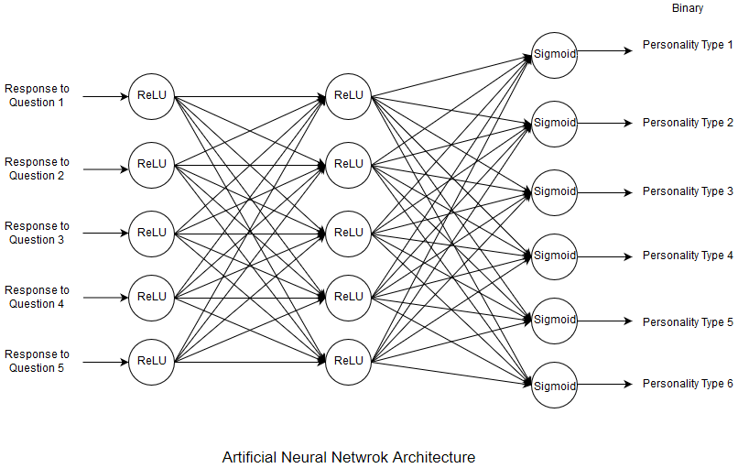

After training this network for 800 iterations at a learning rate of 0.07, the model was able to predict the personality of a user with an accuracy of 85.64% and an error of around 0.74. The graph below shows the convergence of error with number of iterations. It can be seen that the error is reducing after each iteration and the model has converged to a point where the error is just 0.7443

An Artificial Neural Network (ANN) is chosen because the datasets handed by e-commerce platforms are massive and very dynamic. An ANN is proven to perform better with large datasets.

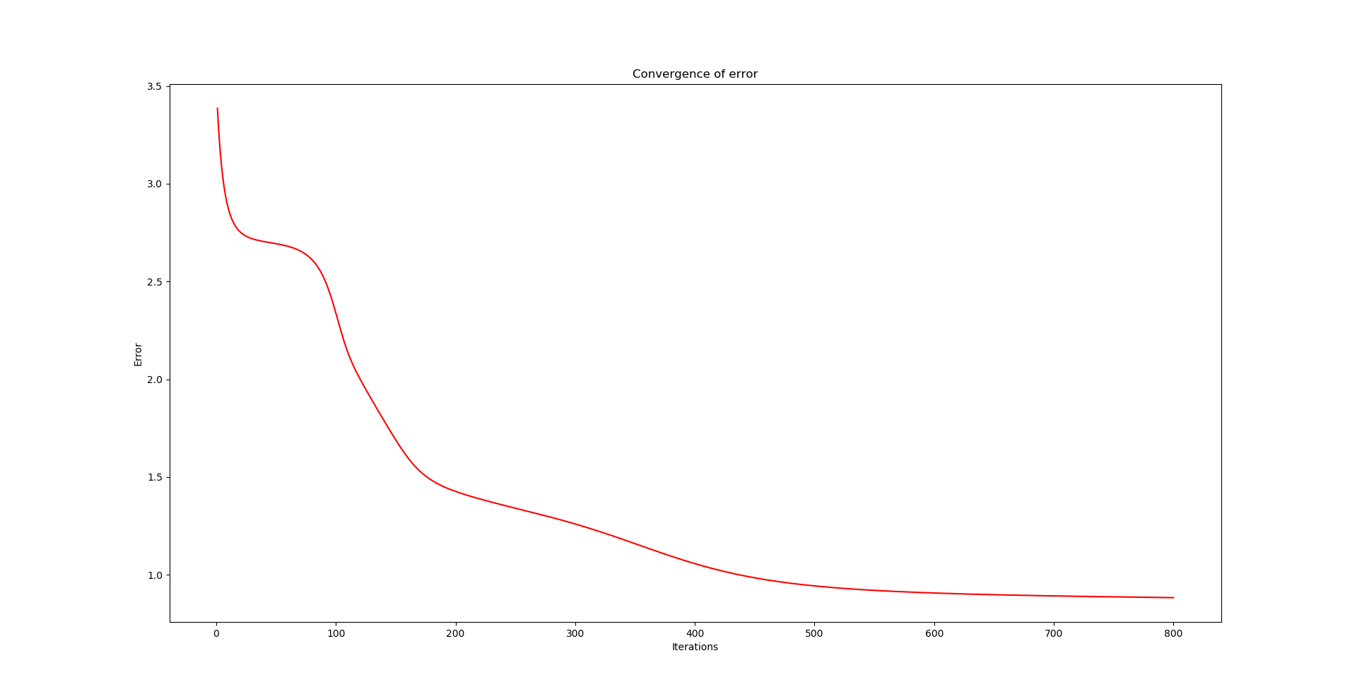

**Smart Recommendation Engine Stage:**

Once the user and its personality type is identified, we need to recommend products to the user based on his personality type. This requires understanding what product is and will be prefered by whom.

Learning this can be done by observing customer buying patterns and then assigning personality (mostly prefered by) feature to that product. **But a better method would be to do a product image analysis**.

A CNN could be made to perform image feature extraction of the product based on the Big Five model and hence get scores for the five fields respectively, in tern learning the product type. Then the product can be recommended to the user based on the user’s personality type and the product type. For the sake of implementation of the prototype, the prior method is used.

The Amazon dataset has 10 columns of which 5 were used as features for the recommendation model. This dataset was merged with the user personality data to sort and then segregate the products based on product ratings and user personality, respectively.

The Amazon dataset has 10 columns of which 5 were used as features for the recommendation model:

|  |  |  |
| --- | --- | --- |
| **Column** | **Description** | **Used ( ? )** |
| Id | Row Id | NO |
| ProductId | Unique identifier for the product | YES |
| UserId | Unique Identifier for the User | YES |
| ProfileName | Profile name of the user | NO |
| HelpfulnessNumerator | Number of users who found the review helpful | YES |
| HelpfulnessDenominator | Number of users who indicated whether they found the review helpful or not | YES |
| Score | Rating between 1 and 5 | YES |
| Time | Timestamp for the review | NO |
| Review | Brief summary of the review | NO |
| Text | Text of the review | NO |

# 